Ticketing Systems

Ticketing systems:is a software used to track, manage and reslove inquries compliants or techical issues for people working in IT Roles

- Creating ticket using jira service management User reports passwords are not accepted. Attempted passwords reset, issue persists
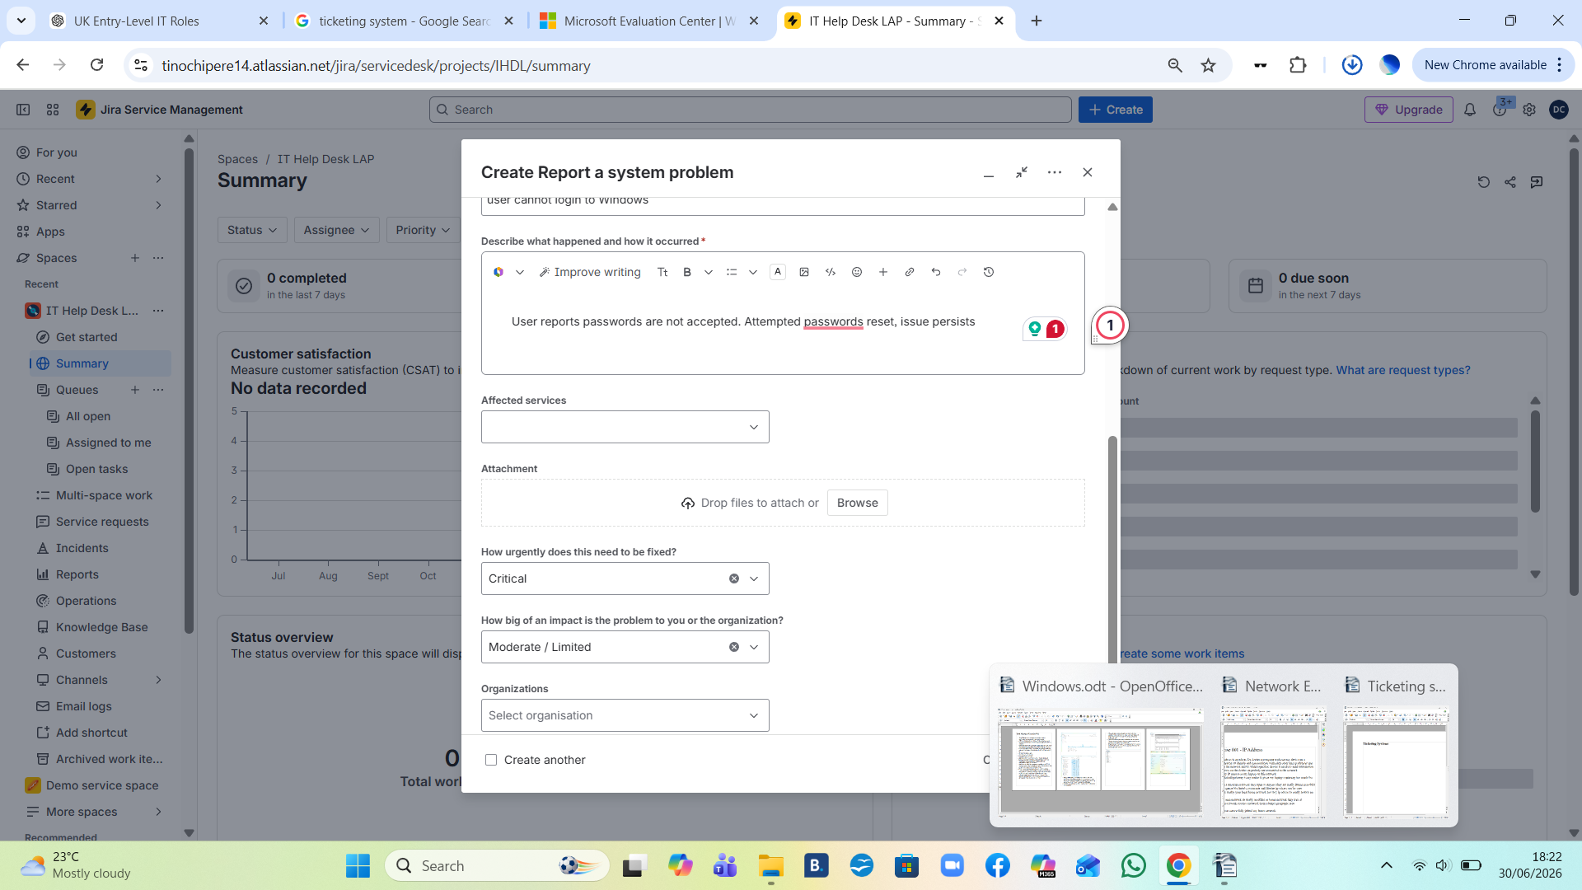
- adding notes:User reported Windows login failure.Investigated credentials and verified account status.Password reset performed and user instructed to retry login.User successfully authenticated after password reset.Issue resolved.

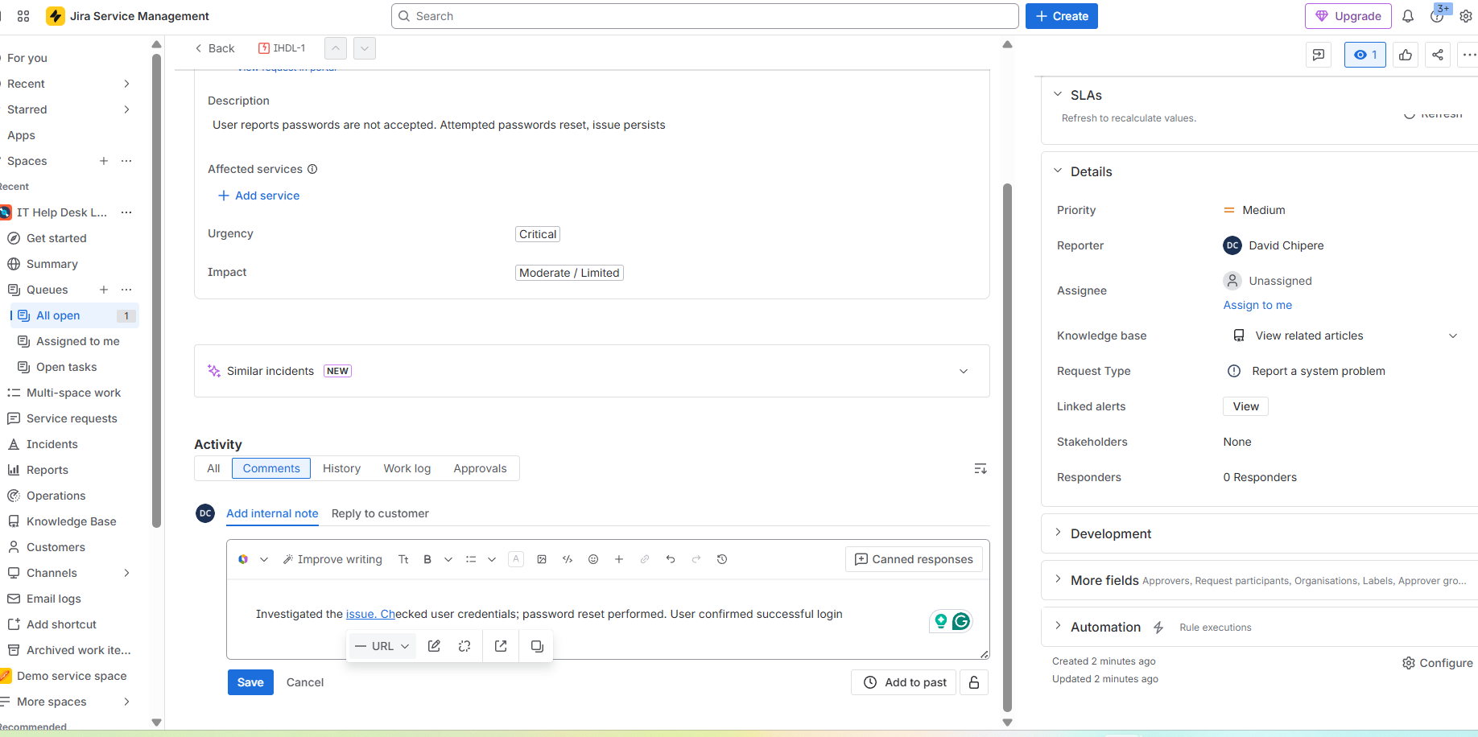
3.Issue resloved

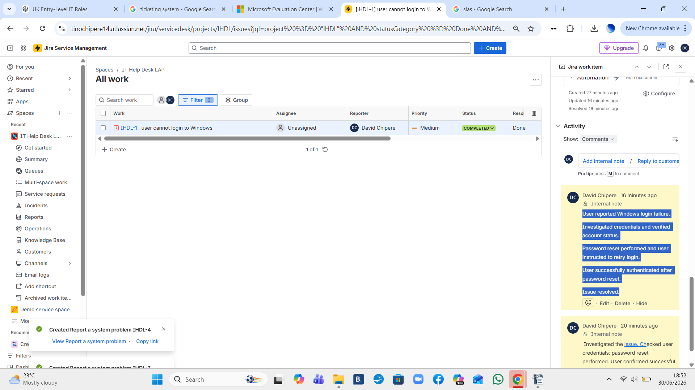
4. More Incidents that need to be resolved
